Cloud Kitchen Expansion in Kathmandu

1. Data Collection and Preprocessing
For this project, I utilized a dataset comprising restaurant details, menu items, and pricing from Foodmandu. The goal of this analysis was to identify optimal locations for a new "Cloud Kitchen" (delivery-only restaurant) by analyzing pricing trends and regional competition.
Initial data preprocessing required significant text cleaning. The Price column was converted from a string format with commas into a usable float format. The Location column was split to extract a clean Area feature. Irrelevant or highly sparse columns, such as Description/Ingredients, were dropped. Finally, outlier detection via boxplots revealed extreme data anomalies (menu items priced over NPR 40,000), which were successfully filtered out alongside duplicate rows to ensure statistical accuracy.

2. Feature Engineering
To perform a deeper strategic market analysis, I engineered three new vital features:
- Price Tier Categorization: A binning technique (pd.cut) was used to classify every menu item into 'Budget' (0-500 NPR), 'Mid-Range' (500-1500 NPR), or 'Premium' (>1500 NPR).
- Menu Count: Grouping by restaurant, I calculated the total number of items each restaurant offers to measure menu diversity.
- Area Restaurant Count: By grouping the data by Area and counting unique restaurant names, I created a definitive metric for "Market Competition" in every specific neighborhood.

3. Exploratory Data Analysis & Visualizations
A. Pricing Distribution and Tiers
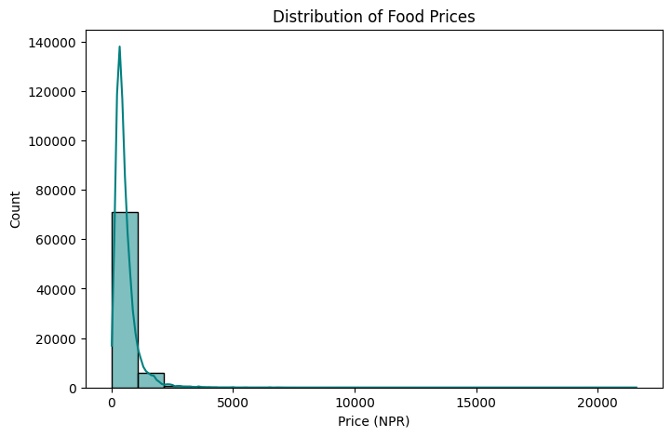
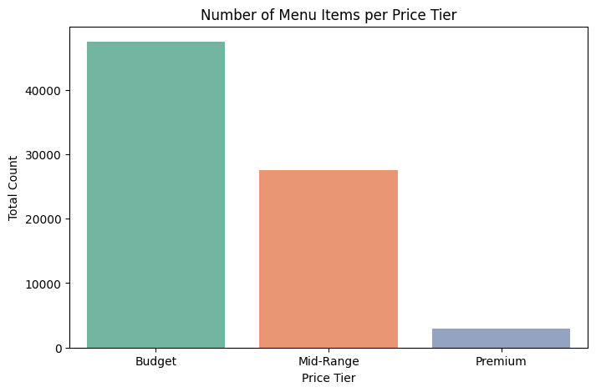
The price distribution analysis reveals that the Kathmandu delivery market is heavily skewed toward affordability. The vast majority of menu items fall strictly within the 'Budget' tier (under 500 NPR), with a steep drop-off as prices move into the 'Mid-Range' and 'Premium' segments. This indicates high price sensitivity among standard delivery consumers.
B. The "Gold Mine" Quadrant Analysis
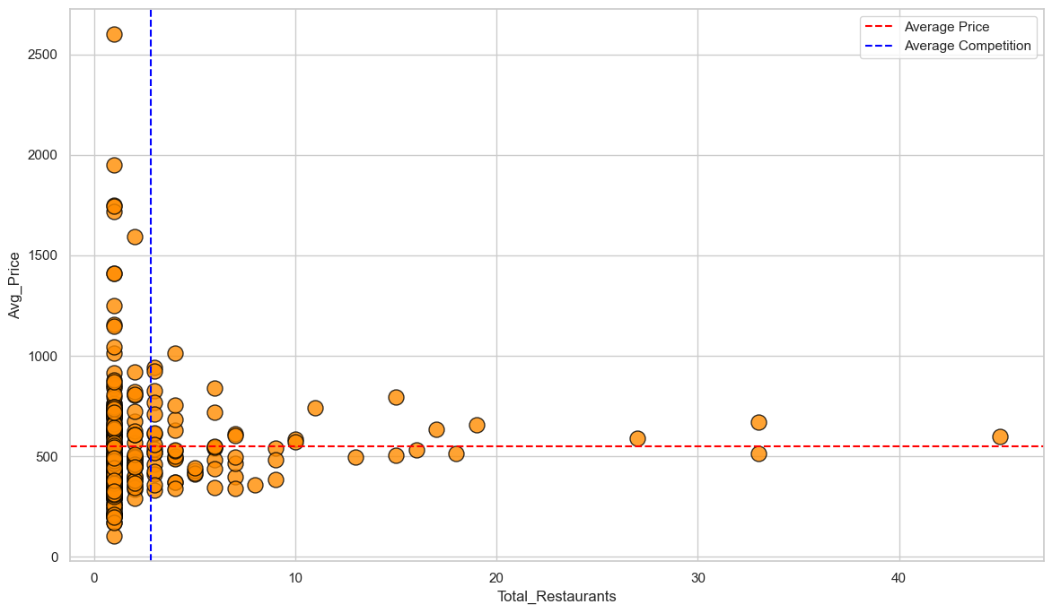
To pinpoint the best location for a new business, I aggregated the data by Area, plotting the Total Restaurants (Competition) against the Average Menu Price (Profitability). By overlaying the market averages (the red and blue dashed lines), the chart is split into four quadrants. The top-left quadrant represents the "Gold Mine" areas: neighborhoods that have below-average restaurant competition but above-average menu prices.

4. Advanced Machine Learning Preparation
To prepare the dataset for future predictive modeling (such as predicting the success rate or optimal price of a new menu item), advanced preprocessing was applied. The categorical Price Tier was label-encoded into numeric values (0, 1, 2). Additionally, numerical features with varying magnitudes (Price, Menu Count, and Area Restaurant Count) were standardized using StandardScaler (Z-score scaling) so that a machine learning algorithm could process them without magnitude bias. The final dataset was exported as cloud_kitchen_ml_ready.csv.

5. Final Conclusions
The data analysis provides a clear strategic roadmap for launching a new cloud kitchen in the Kathmandu valley. While the general market is flooded with budget-friendly options and high competition in central hubs, the quadrant analysis identified specific underserved, high-value neighborhoods. Areas such as Bachapokhari and Kandevtasthan exhibit incredibly low restaurant competition but sustain high average order prices. A premium or specialized cloud kitchen launching in these specific areas would face minimal immediate competition while operating with high profit margins.

